Kelompok 8 :

Haris Saputra 1301174227 : No.1 Parallel Ping & Serial Ping

Abdullah Azzam 1301174360 : No.2 Client Thread

Salman Rachmadi 1301174440 : No.2 Server Thread

Jaish Muhammad 1301174542 : No.3 Download File

1. Parallel Ping

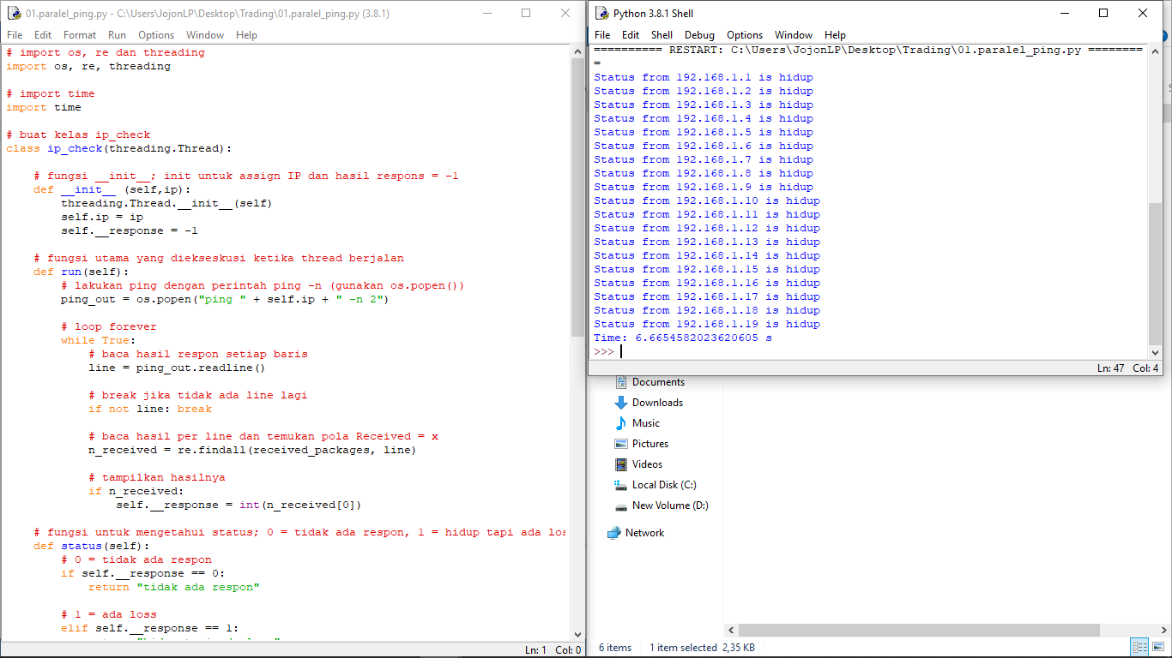

Serial Ping

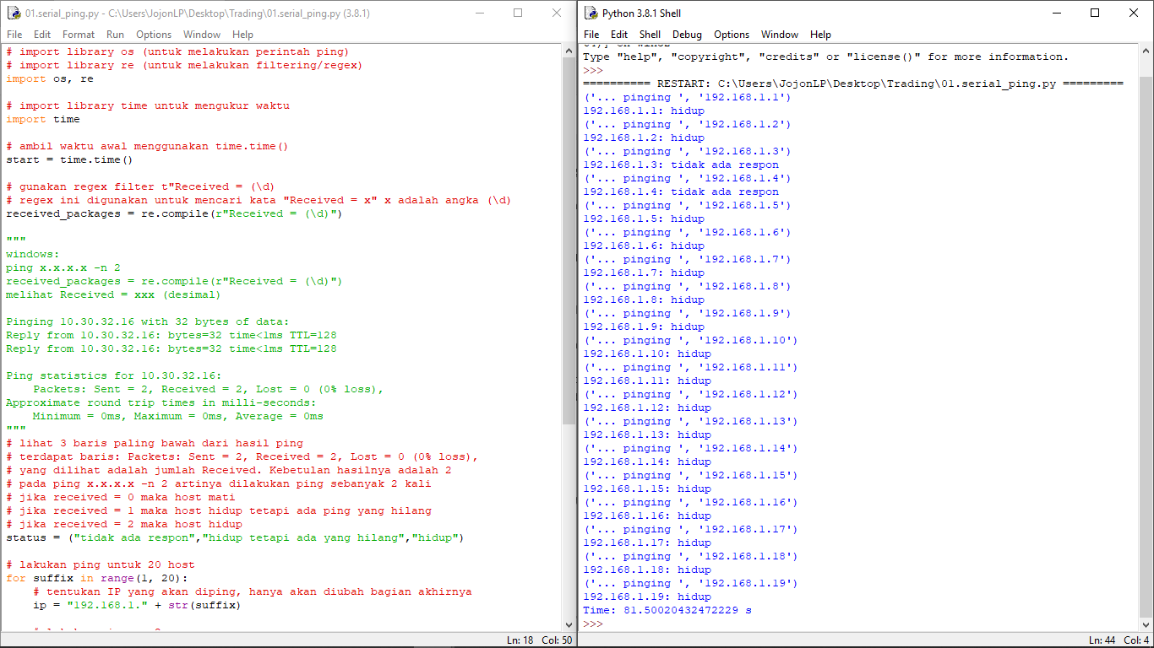

1. Server Thread

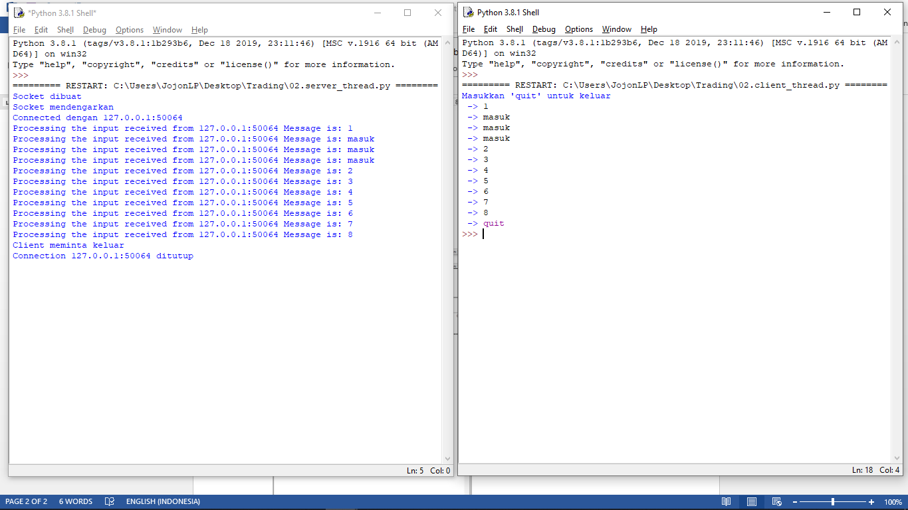

Client Thread



1. Download File

